Project Design Phase-II
Data Flow Diagram & User Stories

Date | 20 February 2026
Team ID | LTVIP2026TMIDS28544
Project Name | Gemini Historical Artifact
Maximum Marks | 4 Marks

Data Flow Diagrams:
A Data Flow Diagram (DFD) is a traditional visual representation of the information flows within a system. A neat and clear DFD can depict the right amount of the system requirement graphically. It shows how data enters and leaves the system, what changes the information, and where data is stored.

. 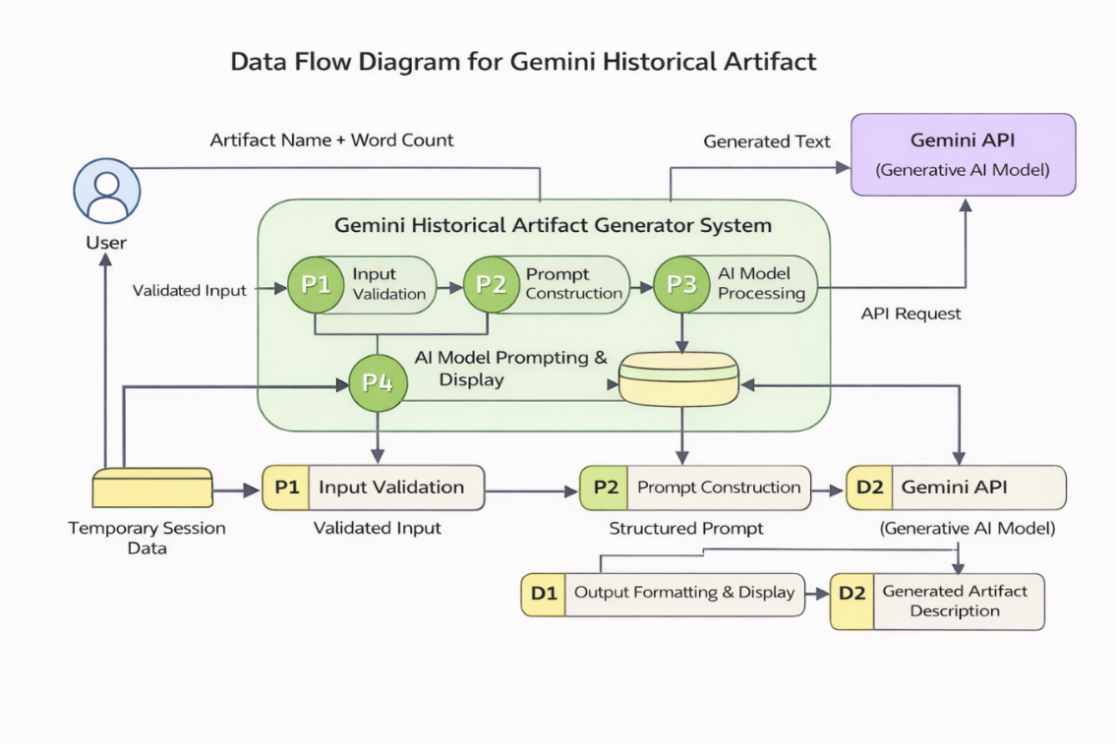

User Stories
Use the below template to list all the user stories for the product.
User Type | Functional Requirement | User Story No | User Story | Acceptance Criteria | Priority | Release
Student / Researcher | User Interface Setup | USN-1 | As a user, I want to enter an artifact name and word count easily. | I can access and input data successfully | High | Sprint-1
Administrator | Input Validation | USN-2 | As a user, I want input validation before generation. | System prevents invalid inputs | High | Sprint-1
Research Professional | AI Integration | USN-3 | As a user, I want the system to generate artifact descriptions using Gemini AI. | AI generates structured content | High | Sprint-2
Student | Historical Fact Feature | USN-4 | As a user, I want to see an interesting historical fact while content loads. | Fact appears during processing | Medium | Sprint-2
User Type | Functional Requirement | User Story No | User Story | Acceptance Criteria | Priority | Release
Student / Researcher | User Interface Setup | USN-1 | As a user, I want to enter an artifact name and word count easily. | I can access and input data successfully | High | Sprint-1

